
Port Seton Resource Centre Newsletter 2013


New programme starts 2nd Sept 2013
Farewell summer, hello autumn and winter. Yes it’s time to forget about trips to the beach, sun-cream and sandals and safari parks. Hello Zumba, country dancing, singing and college work. Our new programme starts on 2nd September 2013 and if it is half as popular as the summer programme we will all be cushti. Thanks for all the positive feedback and I hope you all had a wonderful, sunny, fun packed summer.

Carers Group Request
Please read the Important Diary Dates and Information pages for details on how to set up and get involved with this group.


Partners in Advocacy
Andy Murray from Partners in Advocacy is now in post and coming in regularly to speak to the Members Council and promote speaking up generally.

Masquerade Ball – 13th Dec 2013 7:30/11:00
Our new Arts Project run by Fiona Crombie will for the first eight weeks concentrate on making masks and paraphernalia for our Winter Masquerade Ball.
Care Inspection Report
Our Care Inspection report is available on request from Christine or Bruce and we have been assessed as good overall and scored mostly 5’s in what was assessed. 6 is the highest score. The biggest impact for us will be the introduction of 6 monthly reviews rather than yearly.
Port Seton Events

Blair Drummond Safari Park



Thanks to all who helped and participated in our outing to Blair Drummond Safari Park. Loads to see and do and becoming a welcome regular during our summer programme.

Edinburgh Festival
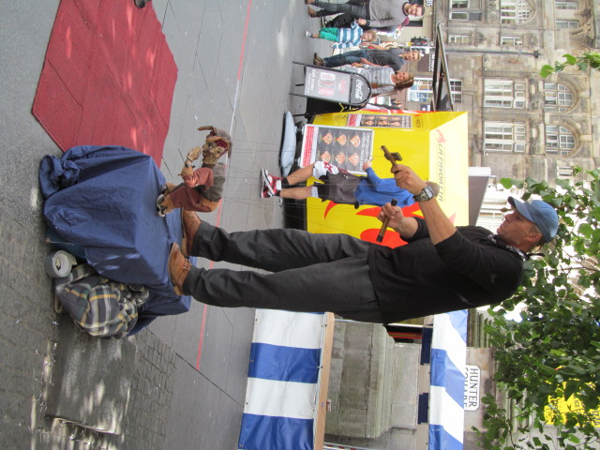

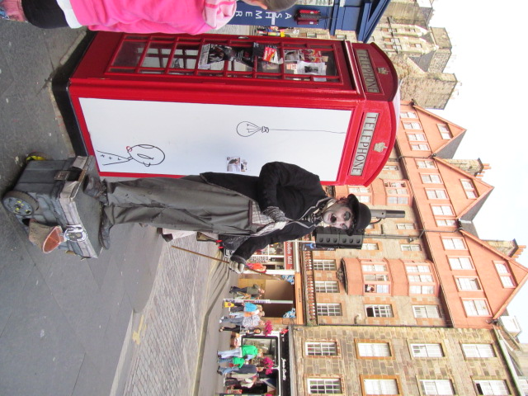

Who can avoid the Edinburg Festival during August? If we could go up to Edinburgh every day we would. Brilliant street performers, great atmosphere, gob-smacking experiences.

Living Local
Some of you may have seen our little bit of celebrity fame as we were featured in the local free press. Lovely day showing the reporter around and showing off the centre. Braw.

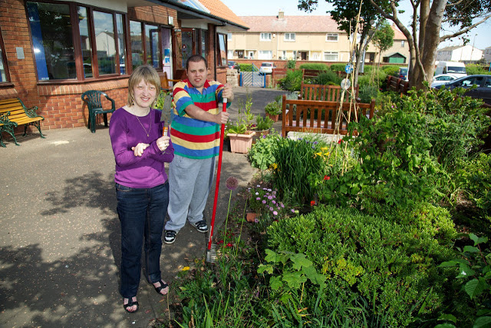
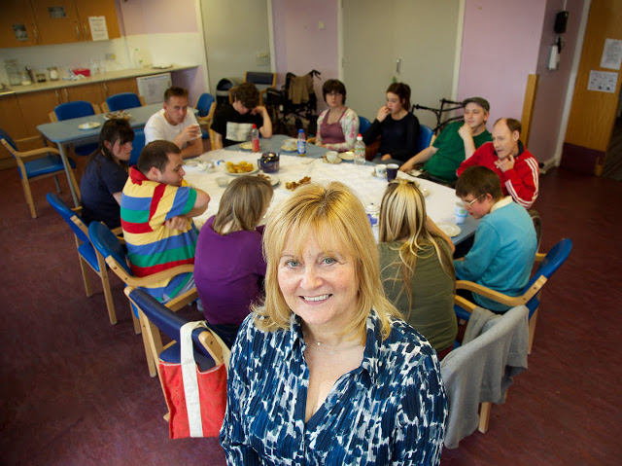
Staff News

Survey Results June 2013

Firstly, thanks to all who contributed or participated in our survey. An 87% response rate I think is very good and provides us with immediate, direct feedback on how our service is perceived. Everyone was asked the same four questions and from these we will:

- Provide more advance notice of upcoming open days/evenings.
- Facilitate a music group.
- Try to bring back the male grooming group.

PS Thanks for all the very appreciative comments, “Brilliant job”, “Big difference in my son”, “Thank you” – they really do boost our confidence and morale. Any suggestions? Feel free to drop in or give Bruce or Christine a call on: 01875 818175.

Fisherrow Hub Evening Drop-In + Tynezone
Just a reminder and invitation to all re our evening drop-in sessions at Fisherrow and Tynebank. An evening of fun, relaxation and social activities. Dates for Fisherrow are:

- Thursday 12th and 26th Sept 2013 6:30 to 8:30
- Thursday 10th and 24th Oct 2013 6:30 to 8:30
- Thursday 7th and 21st Nov 2013 6:30 to 8:30
- Thursday 5th and 19th Dec 2013 6:30 to 8:30
- Thursday 9th Jan 2014 6:30 to 8:30

Tynezone operates on the intermediate Wednesdays at Tynebank. Changes to staff terms and conditions mean we can now officially support these evening activities rather than participate as volunteers.

Important Diary Dates and Information

Carer Group Request

My name is John Buckley and my son attends PSRC. We are once again asking people to consider forming a carers group. There has been little interest in the past, but recently, there has been changes made to transport and there are issues regarding SDS, respite and lots of other things that as a group, we could discuss and make representation at meetings. The plan is to join up with carers from Tynebank and possibly Fisherrow. I currently attend Day Service redesign and Learning Disability Group meetings on your behalf, but I have been unable to pass any information on due to not having a carers group. I would urge you to really consider joining as this is just the start of many changes coming your way and we need to be involved in all decisions that concern any changes to PSRC. There would only be meetings every 2 or 3 months, but these meetings would hopefully be of use to all with up to date information and even could be done by email. My contact details are johncbuckley@hotmail.co.uk and 07747538120. Thanks.

Open Day – October 12th 2013
Another Open Day event is being organised on the above date. Parents, carers and service users are invited to attend for a very informal chat and social and a chance to see examples of what goes on and what we get up to at the centre.

Service User Conference – Feb 2014 – “The Future”
The members council will arrange a conference for S/U’s dealing with the future – moving from home to independent living. Robert Downie – our benefits guru, and a film interview of some peoples past experiences will feature. Stay tuned for further updates.
Port Seton Resource Centre Web Site
As ever recent groups and activities can be found here at http://psrc.org.uk/ using our web site. Full of helpful information and contact details.

Fixed Public Holidays:
Friday 13th September 2013
Monday 16th September 2013

Contact Details:
Phone : 01875 818175
Email : cmaclean1@eastlothian.gov.uk

Transport Numbers:
07899877876 or 01875618651 or 01620827700

